installation manual Biminitop

Thank you for choosing a biminitop of Mijnnaaiatelier.nl !
With a Bimini of Mijnnaaiatelier.nl, you protect yourself and your boat in style against sun and rain. It certainly adds color and style to your boat. The following instructions make assembly and installation easy.

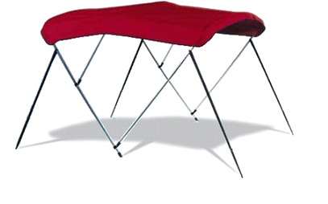
How do you extend the life of your Bimini:
• Ensure that no water or snow stays on top
• Fold the top always carefully
• Allow the top to dry thoroughly before storing it in the sleeve.

Tools required: A drill with a 3 and 2 mm drill bit, a Phillips screwdriver, a flathead screwdriver, a pencil and a tape measure or measuring tape.

Our guarantee: The product is produced by professionals and has no defects upon delivery.
The warranty does not cover normal wear and not wear through weathering. The summit is to be properly attached, should be well maintained and only be used for this purpose for which it was created.
If however it is found defective, wearing my Naaiatelier.en caring for a free repair or replace (at its discretion). Provided that the customer shipping costs to our factory and vice versa prepay. My Naaiatelier.en you reimburse these costs within 14 days of receiving the defective product.
The warranty period of your biminitop bedraagd 2 years on workmanship of fabric and frame. This warranty period starts on the date of purchase.
Wear, user error or improper installation are not covered by the warranty.

LET OP!
Keep the packaging away from children under 3 years i.v.m. verstikkingsgevaar!

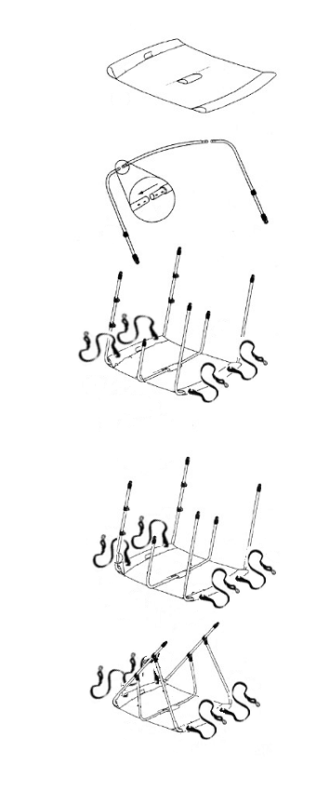
FRAME BIMINI TOP
Step 1. Fold the cloth Bimini upside down on a flat, clean surface, with the sewn label side up.
The label is located on the rear side of the top.

Step 2. Slide a central tube through the rear cover of the fabric (at the label). Take the longest curved tubes and slide it into the straight tube as shown in the drawing. Then use the supplied screws to connect the whole together..

Step 3. Now slide a middle tube by the front cover of the cloth.
Connect the middle size elbow to the center tube.

Step 4. Then slide a central tube through the middle cover of the cloth.
Connect the shortest size elbow to the center tube.

Step 5. Insert short sleeve arch in front of the summit.

Step 6. Grasp the strap and run it for the long arc through the hole in the fabric. Leads the strap over the short bow and buckle the whole.

Step 7. Attach the short frame on both sides of the long frame by means of the coupling pieces. Do the same with the middle frame.

Watch out! If support poles supplied fitted, the rear ratchet straps!

INSTALLATION OF THE BIMINI TOP ON THE BOAT
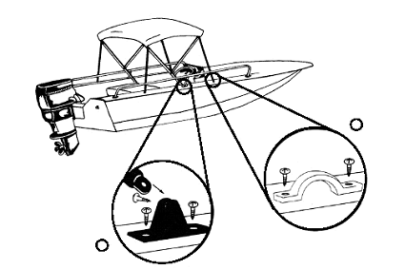

INSTALLING BIMINITOP ON THE BOAT

Step 1. The Bimini is now ready to install on the boat. This is easiest with two people. One to hold the top in place, while the other tag sets where the attachment points should be on the boat.

Step 2. Measure carefully whether the fasteners are exactly opposite each other. If they do not exactly sit opposite each other, the top can be damaged, unstable in use, or crooked eyes.

Step 3. Use a sharp drill bit having a diameter of 3 to 3.5 mm depending on the thickness of the polyester, polyester dicker, for drilling with 3,5 mm. When in doubt, ask your dealer / importer. When drilling in polyester, the hole has to be galvanized in order to prevent the tearing of the polyester. The hardware should be firmly put the screws supplied.

Step 4. Place the top on the boat, with the long frame should be securely fastened to the attachment. Point the top in the desired unfolded position and make the straps tight. The straps serve relative to the boat to have an angle of 45 ° to a maximum of 60 °.

Step 5. Mark the location of the oogbeugels on the boat, make sure again that both oogbeugels exactly sit opposite each other. Use a drill with a 2 mm bit in order to drill the holes for the screws. Countersink the hole of the screw, if there is drilled in polyester. The oogbeugels should be firmly put the screws supplied.

Step 6. Attach the strap hook to the oogbeugel and adjust the strap until it is taut.
Important: Make sure all the connections of screws, hooks and straps are tight.
Regularly check that all connections are tight, screws and imbussen.

Install support poles!
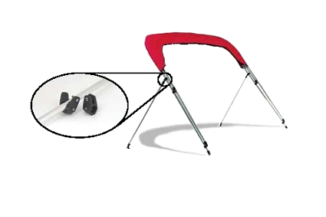
In order to mount the Poles, the top is intended to be folded, but it is standing upright.
Measure exactly the place where the mounting clips should be on the frame, again the markings need to sit exactly opposite each other. Clean the terminals and insert it to the frame in place of the mark and tighten the screws. Place the Poles in the fasteners provided and secure with the bolts. Then determine where the hinges are to meet the boat. The Pole has a corner to make an angle of 45 ° to 60 ° with respect to the frame. To confirm direction of the attachment points, please refer to steps 2 and 3 of the instructions for installing the Bimini on the boat.

Let op! If support poles supplied fitted, the rear ratchet straps!

We hope you enjoy your Bimini!
Mijnnaaiatelier.nl
Beitelstraat 61 G
1135 KV Edam
Netherlands

info@mijnnaaiatelier.nl
www.mijnnaaiatelier.nl
+31645505825

Care instructions:
* Remove dirt d.m.v. brushing or vacuuming the fabric
* If necessary, water (no warmer than 30 ° C) with a mild soap, such as green soap.

* Then rinse the cloth with copious amounts of tap water.

* Fully dry cloth before it is folded.

* Avoid using harsh detergents
* The fabric is not machine wash or spray with a pressure washer.
This makes the Teflon layer disappears and the canvas is not waterproof.
*We sell special cleaners to clean thoroughly again the fabric of your biminitop.
http://www.mijnnaaiatelier.nl/productenwebshop.html - !/Reiniging-en- onderhoud/c/3628116/offset=0&sort=normal
* Please note, after cleaning cloth impregnated with Waterproofing so that the cloth is again water and dirt repellent.

Reiniger 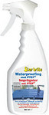 Waterproofing

